



**RESIDENCY GUIDE**

**NON-DISCRIMINATION POLICY**

Admission to the *Spanish Peaks Veterans Community Living Center* is based upon the facility’s ability to meet the needs of the Veteran or Veteran-related individual and without regard to gender, age, creed, race, ethnicity, national origin, sexual orientation, or physical disability. There will not be any discrimination by employees of the *SPVCLC* in providing services to the Residents.

SPRHC/VCLC mission is "To Improve The Lives We Touch" and therefore strive to provide services which allow people to attain their optimal health, regardless of race, ethnicity, disability, sexual orientation, gender identity, socioeconomic status, geography, preferred language, or other factors that affect access to care and health outcomes.

We strive to incorporate health equity into all department functions, including surveillance, planning, implementation, and evaluation to identify and remedy system barriers to equitable services. The organization has a multidisciplinary Diversity, Equity, and Inclusion (DEI) committee, supported by leadership and the Board of Directors, to coordinate these activities throughout the organization.

Revised January 2025

The “Residency Guide” is a compilation of the most asked questions by applicants and their families. The answers will, hopefully, address your more immediate questions and concerns regarding residency at *Spanish Peaks Veterans Community Living Center* (*SPVCLC*). The decision to select a living center is certainly a momentous and emotional event.

A living center does not mean the end of life as you know it but rather enables you to keep living your life with pride and dignity.

We highly respect our nation's Veterans and their spouses. We are aware of the tremendous sacrifices and losses endured by Gold Star Parents. We are here to return the dedication and service given unselfishly by America's Veterans; Veteran spouses, widows, and widowers; and Gold Star Parents. It is our privilege to give assistance to those needing our care during their time of need when they are the most vulnerable. Thank you for allowing us the honor to serve you and your loved ones as all of you have served our great nation.

**APPLICATION FOR RESIDENCY**

**ELIGIBILITY**

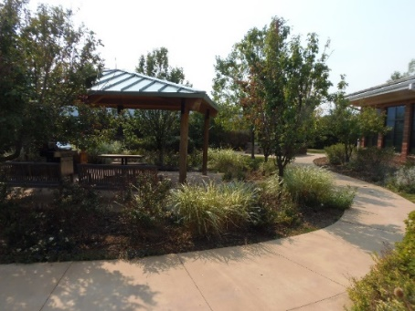We accept Honorably Discharged Veterans, their spouses/widow/widowers, and Gold Star Parents. Please note that Colorado residence is not a requirement. There must be a need for a nursing home as opposed to assisted living or independent senior living which includes requiring assistance with walking, sitting, bathing, toileting, dressing, and/or dementia/Alzheimer's Disease which are considered during the application review process. SPVCLC offers long-term and short-term care stays. Short-term care may also be referred to as a respite stay. Short term, respite stays are normally anywhere from one day up to thirty days and are temporary..

**APPLICATION PROCESS**

If applying for yourself, complete the application and refer to the checklist which names the required documents that must accompany the application. We will need a copy of your military discharge document during the admissions application process. The Admissions Coordinator or the Veteran Service Officer in the county of your state can assist you with this using form SF 180. The form, which requests a copy of the military discharge document (if available), will be submitted to the *National Personnel Records Center* in St. Louis, Missouri. This request may take as long as 2-3 months to process. These include naming a medical and financial representative known as a 'power of attorney' and making your wishes known now for end-of-life care and planning. If you are applying for yourself, then you or your documented authorized representative must sign the documents. If you are applying for someone else, you must be the applicant's document authorized representative such as their Medical or Financial Power of Attorney.

**REVIEW FOR ACCEPTANCE**

After the application and supporting documents are submitted, the *SPVCLC* Admissions Coordinator will request medical records and verify the applicant's medical insurance. Once all medical records are received, the Admissions Committee will meet and assess the applicant's application and medical records. This group consists of representatives of various *SPVCLC* departments to ensure the *facility* will be best suited to meet the applicant's needs. These departments include Administration, the Medical Director, the Business Office, Nursing, Quality Assurance, Social Services, and the admissions Coordinator. If approved by the Committee, the Medical Director conducts a final review for acceptance or denial.

**MEMORY CARE**

Our memory care unit is for those people who may require more assistance and monitoring due to dementia or Alzheimer's Disease. Please note that it is not a "secure unit" for anyone who may require psychiatric care.

**SMOKING/MARIJUANA POLICY**

All employees and residents are prohibited from smoking as we are a smoke-free facility for the health and wellness of our residents. Smoking also presents a fire hazard risk and danger due to the proximity of portable oxygen tanks in the immediate area. If you smoke or are using other tobacco products and need a nursing home, we encourage you to begin the nicotine cessation process as soon as possible. Violation of the non-smoking policy may result in discharge from the facility.

Marijuana and CBD products are currently not allowed per federal regulations. Violation of this policy may result in discharge from the facility.

**PAYMENT TYPES ACCEPTED**

The three accepted payer sources are private pay, Colorado Medicaid, or the Veterans Administration for those veterans with a service-connected disability rating of 70-100%.

If your payer status is Private Pay, please bring the pre-determined payment with you. Also, you may deposit money (cash, check, or money order) to your Personal Needs Account at this time. Medicaid Residents normally do not have a patient payment for the first month of admission. The *SPVCLC* Business Office Manager will discuss other future payment options with you such as a direct debit from a selected financial institution.

**PETS**

Pets are not allowed to stay overnight currently. Pet visitation status may vary, so please call ahead for the current policy before bringing a pet for visitation.

**PRIVATE ROOMS**

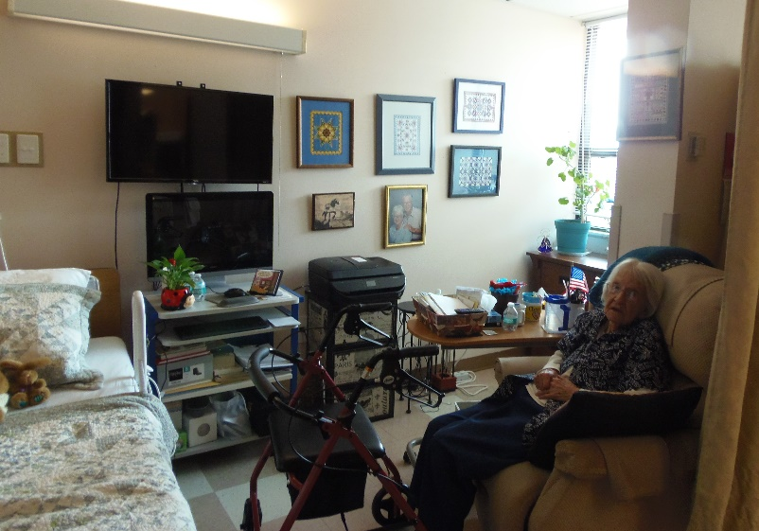

Most rooms are semi-private, which means two people in a room. A new Resident may be placed on the waiting list after admission to one of the seven private rooms, but the length of time it will take to move into a private room cannot be predicted. There are also couples’ rooms available as an option for husbands and wives in cases where they both qualify for nursing home care. Please know room and roommate selection are based on compatibility. You have the right to request a room change at any time for any reason.

We encourage you to personalize your room area.

(Example of one side of a semi-private room)

**PLAN OF CARE**

A group of healthcare professionals called a Care Plan Team will meet with you and your representative and/or family to develop your individualized plan of care. The team meets a minimum of every three months to review your plan of care and identify your strengths, weaknesses, and care needs so you may enjoy a better quality of life. The group will help you establish goals and set in place the techniques to achieve them. The meetings are held in person or via a conference call.

**ADMISSION HAS BEEN APPROVED**

After approval, the applicant and/or their POA will be notified, and a date/time will be set for the admission. We will adjust the admitting policy as necessary based on the current pandemic regulations

**ADMISSION PERIOD**

It varies, depending on if the complete checklist was submitted as medical records cannot be requested incomplete. Medical records are requested via facsimiles from the medical entities that were provided with the application packet. Many medical entities outsource their medical records storage which may add to a delayed response. Overall, requested medical records may be returned the same day as the request was made or several weeks depending on the entity.

**PERSONAL ITEMS**

The admissions Coordinator will supply two sets of inventory forms which must be completed before admission and returned to the coordinator upon admission.

* The 'Inventory of Personal Possessions on Admission' form lists wearable items. You will need to provide basic descriptions, for example "Short-sleeved T-shirts", and the number of each item type. Laundry is collected and processed every day; it is suggested that no more than seven days of clothing be brought due to limited storage availability. Three days’ worth of clothing should be bagged separately so those items can be worn while you are waiting for the main laundry of items to be completed. These items will also need to be labeled prior to being placed in your room. All wearable items will be taken directly to the Laundry Department where those items denoted on the inventory sheet will be verified. Printed name labels will be adhered to each item upon being laundered. Placing the wearable items in large, disposable, plastic bags is suggested as the rooms cannot accommodate luggage. Clothing hangers will be provided.
* The 'Inventory of Personal Possessions on Admission (Special Value)' form reflects non-wearable items. Please use discretion when bringing high-value items such as jewelry. It may be best to bring only a limited number of such items and later have family members change those items out for others as time goes by or when needed. All jewelry/watches will be photographed.

**VALUBLES**

We try to minimize the loss and misplacement of our Residents’ personal belongings but cannot always guarantee their security. Please consider whether jewelry, expensive clothing and accessories, fragile personal items, and excessive amounts of cash can be properly protected if left at the *SPVCLC*. There is a small lock box secured to an inside bedside cabinet drawer, and you will be given its key on a lanyard should you choose to wear it. However, it is suggested that a minimum of whatever is valuable to you and no more than $20 in cash should be kept in your room The Admissions Coordinator will have discussed an in-house Personal Needs Account (PNA) with you or your representative before admission. The PNA offers a secure way to keep your personal spending money available until you need it.

**TELEVISIONS**

A flat-screen television measuring over forty inches is too large for the rooms, although the room size and its set-up may vary. A television weighing over thirty pounds will need to include a wall mount that you provide. Our Maintenance Department will connect your television to our basic DISH network cable TV system. Your television will be on the wall with the pre-installed wall mount. A personal listening device such as wireless headphones is recommended., This will allow you to listen to your TV at whatever time of day or night without disturbing the other person in the room.

**MEDICATIONS & MEDICAL EQUIPMENT**

Although we will have already received your list of current medications, please bring any current prescriptions you are taking for continuity of care.  The facility will provide your medications and order them through Omnicare Pharmacy.  Medications are not allowed to be kept at bedside nor over the counter meds or essential oils. If you receive medications by mail order, these medications need to be discontinued.  Your nurse will be administering your medications at ordered times. Also, please bring items you are familiar with and feel comfortable using such as a wheelchair, cane, walker, CPAP or BIPAP machine, and so forth.   We will provide an oxygen concentrator if in need of oxygen.

**RECLINERS**

We suggest recliners be leather, vinyl, or Naugahyde for infection control reasons, but all are accepted, including fabric. Please remember to keep the chair's safety precautions in mind.

**BASIC ITEMS**

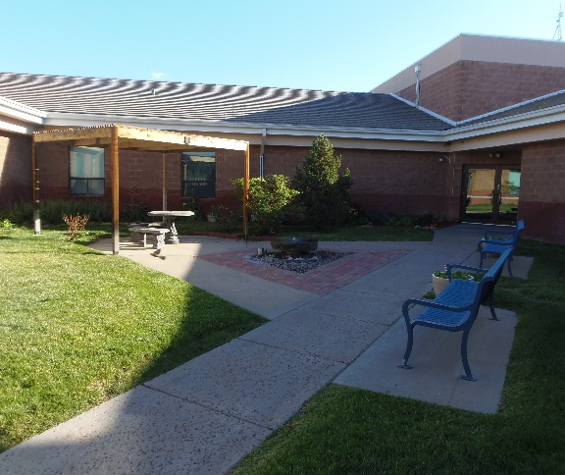

Although the *SPVCLC* supplies linens, pillows, and basic toiletries, you may want to bring your favorite comforter/blanket, pillow, and preferred toiletries to make the transition easier with items with which you are comforted. Our Activities Department personnel will gladly pick up items for you, but you will need to assume monetary responsibility for those purchases. The Maintenance Department will provide hospital-grade power strips should any electrical extension cords be necessary. No rugs please, they pose a tripping/fall hazard.

**REFRIGERATORS/MICROWAVES**

There are full-size community refrigerators, but bringing in a small, private refrigerator for your living area is acceptable. A sturdy, small table (with or without drawers) to place the refrigerator on is recommended so bending down to access is not a safety issue. Personal microwaves are not allowed in rooms for safety reasons, but staff will gladly heat anything you need.

Secondary outdoor area for Residents to enjoy!

**TELEPHONES/COMPUTERS**

You can bring your personal cellular phone. The facility offers complimentary Wi-Fi. You may also opt to use the room's landline telephone service (two lines in a semi-private room) along with a basic handset we provide. Should you wish to bring in your own landline telephone with various features, please check with the Admissions Coordinator first to ensure its compatibility with our system. Each room area has its own three-digit extension so calls may be received directly in the room. If you need help placing a call on your cell phone or room phone, we will be happy to assist. Residents use their computers for entertainment purposes or to stay connected with friends and families. A shared computer is available for your use.

ADMISSION DAY

Upon the pre-arranged day of admission, the Maintenance Department will assist with unloading any personal items and transporting them to your room. Please bring inventory sheets with you.

The admissions Coordinator will review the admitting documents with the accepted resident and/or their power of attorney or representative, which will need to be initialed and signed. Your valuable items such as watches, and jewelry will be photographed. The photos will be placed in your administrative file for future reference. You or your representative will be provided with a copy of the admissions documents. Upon arriving at your room, your picture will be taken for your medical file. Your new friends and caregivers will be extremely excited to meet you.

The Charge Nurse and Certified Nursing Assistants (CNA's) will record your vital information such as weight, blood pressure and review your medical history with you. The nurse will also take note of any concerns you may have regarding your medications and medical issues. A facility physician will visit you within 72 hours of your admission.

The Nurses, CNA's, Hydration Aides, Housekeeping, Maintenance, Dietary, Activities, and administrative staff will help you get acquainted with all the wonderful amenities we have to offer.

**LEAVING THE FACILITY**

**MEDICAL APPOINTMENTS**

Our Transportation Coordinator will ensure you make all your medical appointments and, as necessary will schedule new ones for you. One of our transportation drivers will take you to your appointment and accompany you during the examination if you wish. Please bring a list of your previously scheduled appointments with the name of the medical entity along with the date and time of each appointment and we will do our best to get you to those. However, re-scheduling may be necessary due to transportation conflicts.

We are situated on the second floor of the facility with access to three grassy outdoor areas for you to enjoy. We encourage you to use our sunscreen whenever you choose to go outside to walk, read a book, or stretch out on the lawn. There are also above-ground garden beds which are just waiting for green thumbs.

**MEALTIMES**

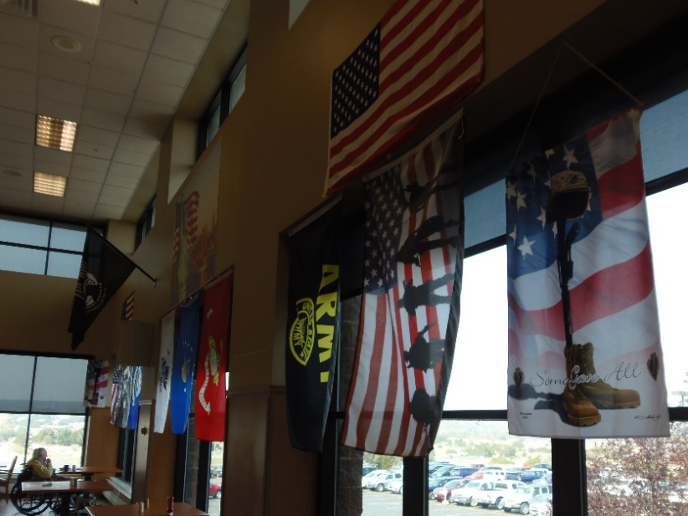Main meals are served in the spacious dining room with breakfast available from 7:30-9:00 am, continental breakfast from 9:00-10:00 am, lunch from 11:30 am to 1:00 pm, and dinner from 4:00-5:30 pm. You will be able to select breakfast from a menu and choose from a choice of two entrees at lunch and dinner in addition to grill-order items.

Input regarding the food being offered or anything dietary-related may be addressed at any time. The food committee, headed by the Director of CSG Dietary, meets with residents the last Tuesday of each month at 2:00 pm to allow residents to provide their feedback and suggestions on menu choices.

Front/side view of the Mountain View Dining Room

**FOOD BETWEEN MEALS**

In addition to breakfast, lunch, and dinner you can request a snack in between meals. You're welcome to get a refreshment from the open beverage bar in the dining hall or our staff will be happy to get it for you. We have a variety of items available to include fruit, sandwiches, cookies, candy bars, ice cream, chips, and more.

**EATING IN ROOM**

You can absolutely eat in your room; however, our staff is to encourage you eat your meals in the dining hall. It is healthier for you to move your body and sitting in an actual chair will make it easier for you to eat and digest. Our Dietary Department staff will be better able to address your dining needs such as refilling your beverage or getting you that extra serving. For safety, should there be an unexpected swallowing or choking issue, staff are in the immediate area to assist.

**ALCOHOL**

Alcohol is allowed in moderation if your attending physician approves its consumption. For the safety of all residents, alcohol will be kept locked up and only the Charge Nurse will have access to it.

**BATHING**

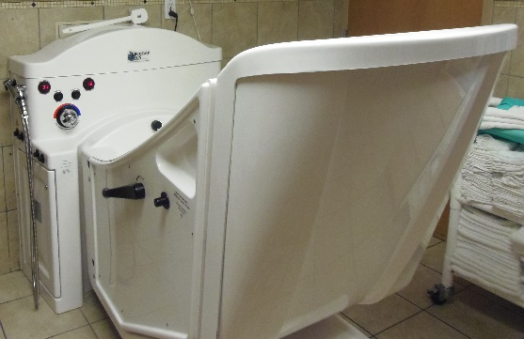If you can bathe yourself, you can do so in the main bathing rooms, privately in one of the curtained shower stalls. We have flexible bathing times depending on your preference.

We have spa tubs that have water jets that are very relaxing! A tub side-door safely allows for tub entrance and exit. The tub design enables a person to sit on an installed seat as if sitting in a chair. The tub can then be moved up/down and at varying degrees of incline for a full-body soak.

**MAIL**

The mail will be delivered to you by the Activities Department Monday through Saturday. All mail needs to be addressed to your name, 23500 US Hwy 160 Walsenburg, Colorado 81089. You and your Financial Power of Attorney can decide if it is best to submit a change of address or contact certain senders directly with an updated address.

Spa Tub



**ACTIVITIES**

The Activities Department offers a wide array of interests to take part in which include arts & crafts, bible study, bingo, card games, communion, country drives, group activities, group exercise, hobbies, trivia questions, television, and movie time complete with popcorn and a cold drink. We also offer church services, fishing at *Lathrop State Park*, the pet companion program, and live entertainment from singers, bands, guitarists, pianists, and dancers.

OTHER TOPICS

**BRINGING NEW ITEMS AND TAKING OTHERS OUT**

When any added item is brought into the *SPVCLC* after admission for you, please make certain it is properly labeled with your name. It may be taken directly to the *SPVCLC* Unit Secretary for inventory. Likewise, if an item is being taken out of the nursing home, the Unit Secretary will need to be advised so it is removed from your inventory list.

**DESIGNATED BEDTIME**

There is not a designated bedtime, however, to allow the other residents to have the best comfort and quality of life, we ask for your cooperation by respecting quiet hours beginning at 8:00 pm until 7:00 am. These are times when your personal listening device may come in handy. If you choose not to use headphones, you may watch television in your room with the volume low or there are televisions in the shared areas for your enjoyment.

**GRATUITIES**

Employees are not permitted to accept tips, meals, loans, gifts, or any other gratuities from residents or their families. Acceptance of such gratuities could result in immediate disciplinary action up to, and including, termination of the employee. However, items that may be shared by an employee group (such as CNA's, nurses, and other employees) are always welcome. Examples are cookies and candy, shared items such as gift baskets, pizza, etc.

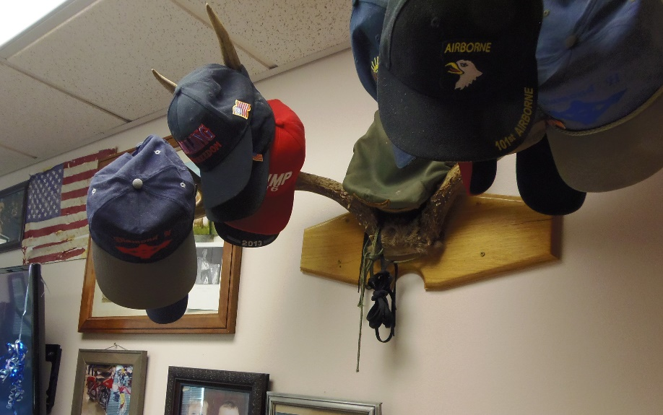

**BEAUTICIAN OR BARBER SERVICES**

We do have a beautician/barber come to the facility weekly. The cost of hair care is not covered by the *SPVCLC,* but the fees may be taken directly out of your PNA with authorization.

**RESIDENT COUNCIL**

The Resident Council consists of residents and provides a forum to offer suggestions and share concerns and issues. The group also administers financial donations made on behalf of the residents. The president, vice-president, and secretary of the Resident Council officers are actual residents of the facility elected by their peers. All residents are invited to attend the monthly meetings scheduled for the third Tuesday of each month at 1:00 pm in the Greenhorn Room.

**GRIEVANCE PROCESS**

The *SPVCLC* has a grievance policy and procedure whereby residents are encouraged to communicate any grievances with the assurance that their grievance will be addressed. The Charge Nurse is available 24/7 to listen to and process your grievance. The Nursing Home Administrator is the *SPVCLC* Grievance Officer. The administrative and management staff are also open and responsive to your concerns. You will be provided guidance throughout the grievance procedure whenever needed. There is also an ombudsman to speak with if, for any reason, you feel more comfortable conveying your concerns to that person instead. The ombudsman, whose specific area of concern is assisted living and nursing home facilities located in southern Colorado, may become your advocate on your behalf.

**DISCHARGING HOME OR TO ANOTHER NURSING FACILITY**

We ask that you notify us as soon as possible and at least seven days in advance if you are planning to leave the *SPVCLC* permanently. This will allow us time to obtain discharge orders from your physician, organize paperwork, and make plans to ensure a safe and smooth transition for your move. Social Services and the nursing departments will discuss your options should you wish to be discharged to home or to another nursing facility. We ask that a resident's personal items be removed from the room within 72 hours of their departure. Please contact our Social Services Department should other arrangements need to be made. A resident must have a safe place to discharge before leaving the facility. Colorado Choice Transition Services are available to eligible residents that are interested in transitioning out of long-term care facilities back into home and community-based settings.

**EMERGENCY PROTOCOLS**

The *SPVCLC* is committed to the safety of the residents. We have comprehensive plans and procedures already established to respond to emergencies or disaster events.

**QUESTIONS/SPVCLC TEAM**

If you have a question or concern that is not addressed here, please contact the admissions coordinator. Below is a partial listing of staff whom you may also contact directly. Each person will appreciate the opportunity to answer your questions and address any concerns.

**NURSING HOME ADMINISTRATION**

Teresa Clift, VP of Senior Care/Nursing Home Administrator (719) 738-5197

**MEDICAL AND NURSING STAFF**

Dr. Michael Moll, Medical Director (719) 738-4590

Nancy Corsentino, Director of Nursing (719) 738-4511

**ADMINISTRATIVE MANAGEMENT STAFF**

Dave McGraw, Dir of Safety, Security, & Emergency Preparedness & Response (719) 738-5145

Anthony Aldretti, Director of Facilities Services (719) 738-5170

****Shanna Cook, Activities Director (719) 738-5136

Lainie Tenorio, Admissions Manager (719) 738-4565

Bryan Ortiz, Social Services Director (719) 738-4519

**OTHERS**

Deborah Wilson, Ombudsman (719) 845-7329

Roger Watkins, SPVCLC Veteran Service Office (618) 746-1419

Anonymous Compliance Hotline Number (800) 273-8452